PAULO RICARDO SANTOS SANTOS DA SILVA
010.190.002-36
R. AGENOR MARTINS DE CARVALHO, 878
PORTO VELHO RO

MMC/L200 4X4 L
2001/2002
93XLNK3402C115285
NBX5898
00765658810
BRANCA

4 CILINDROS DIESEL
2.477
4D56KH0262
87
25331

4 CILINDROS DIESEL
2.477
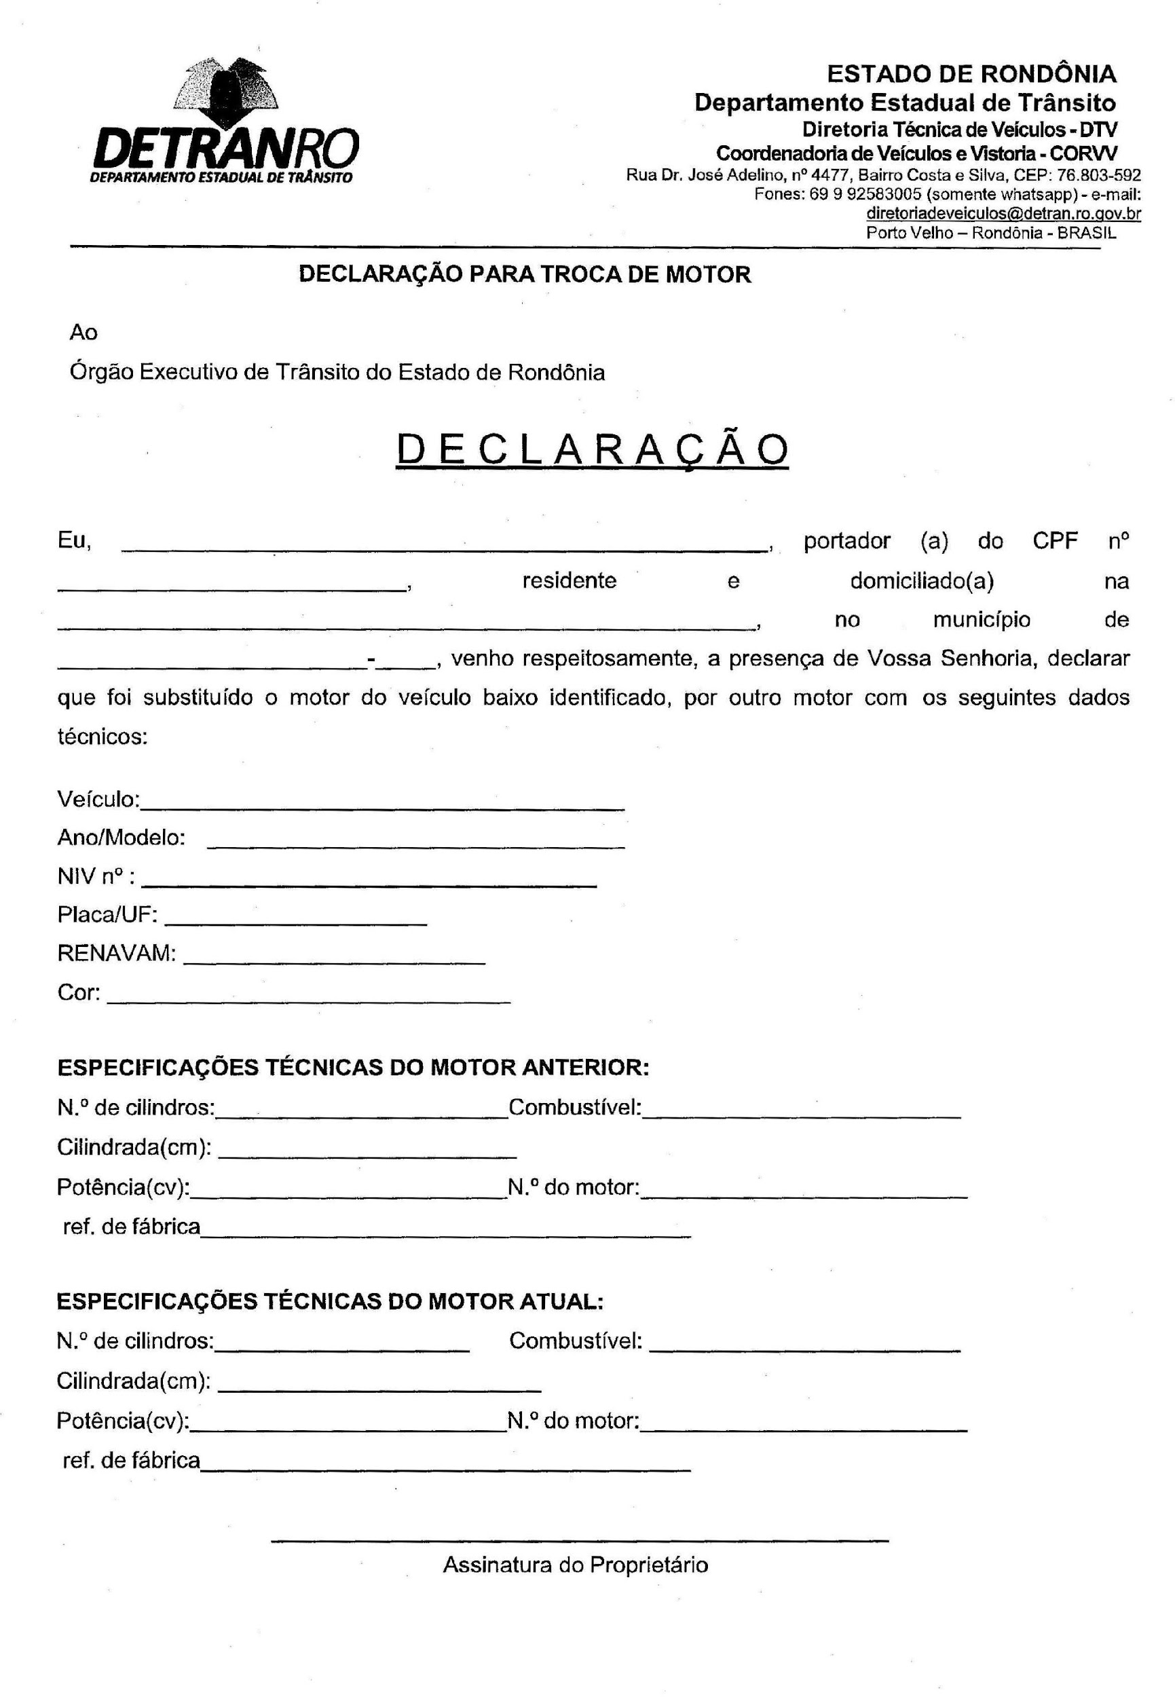
87
25331
4D56KH2684

